From the Badass Digest website with the following URL:
http://badassdigest.com/2012/06/11/badass-hall-of-fame-vito-russo/

Published June 11, 2012 by Meredith Borders

Badass Hall of Fame: Vito Russo
Protector of gay rights, AIDS activist, film historian and author of the revolutionary CELLULOID CLOSET. Ladies and gentlemen, Vito Russo was a badass.
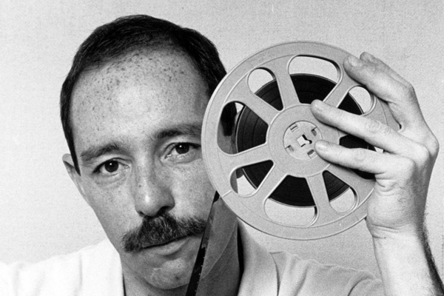
Of all the things that made Vito Russo special, the most remarkable is that he never felt guilty about being gay. He was born in 1946 and grew up in a traditional Catholic Italian family in East Harlem and New Jersey in the ‘50s and ‘60s, yet he never allowed the oppressive influence of tradition, religion, family and cis-masculinity to convince him that he was born as something unnatural. When Vito was a teenager in 1960 New Jersey, he did what he had done so many times before out of habit: he went to confession to ask for absolution after having sex with a man.
"And of course [the priest] recognized my voice because, you know, every week he was hearing me say this, so he says finally ‘Look! Enough is enough! Next time I’m not giving you absolution!’"
At that moment, Vito was free. He realized that he didn’t care if the priest absolved him, that on some level he’d never believed that his homosexuality was a sin requiring absolution. Suddenly he knew "there was nothing wrong with being gay, that [the church] was full of shit and this was all just a guilt trip…If being gay could be so natural to who I was, then it had to be okay. I also knew that my only real choice was to express it openly."
From that point forward, one of gay rights’ most vocal activists was born.
Despite living in an area where machismo was valued over all else and therefore getting beat up on a regular basis, Vito loved his home due to its proximity to theatre and cinema. He was a passionate lover of drama from his first memory, constantly getting in trouble for sneaking out and organizing neighborhood-wide expeditions to Broadway and the cinemas of Manhattan. He could quote verbatim long segments from It’s A Wonderful Life (1946), Miss Sadie Thompson (1953) and Somebody Up There Likes Me (1956). He lived for double and triple features of monster movies like Creature from the Black Lagoon (1954) and The Blob (1958). He saved every cent to be spent at the movies, admission for a quarter and hot dogs for lunch.
Vito grew to be an avid storyteller and much of his love of story culture must be attributed to that, but there was something else dwelling beneath the surface of the films that he loved as a child that spoke to him long before he understood that part of himself.
Watching the now infamous homoerotic shoot-off between Montgomery Clift and John Ireland in Howard Hawks’ Red River (1948), Vito recognized something of himself – and this revelation later shaped his passion for gay and lesbian film studies.
"I want to track down what is the sensibility that exists where I could be 14 and sit in a movie house looking at Montgomery Clift in Red River and know that there was something different there that I couldn’t put my finger on."
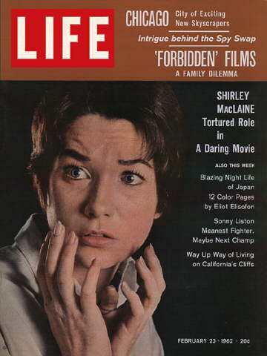
On February 23, 1962, Vito delighted in a Life magazine with Shirley MacLaine on the cover, promoting her new “Daring Movie,” The Children’s Hour (1961). In the film, MacLaine and Audrey Hepburn are schoolteachers accused of having a lesbian relationship. The Children’s Hour is one of the first Hollywood films to present homosexuality as an overt part of the narrative, and it was very well received with five Academy Award nominations and three Golden Globe nominations.
Vito loved the film for that reason, but he also felt uncomfortable with the intense guilt and grief suffered by MacLaine’s character over her lesbianism. She emotionally flagellates herself, violently ashamed of her simple love for another woman. Vito began to watch movies as an archaeologist, digging for tiny glimpses of himself represented among these silver screen gods and goddesses. But it was impossible to deny that the glimpses were rarely favorable.
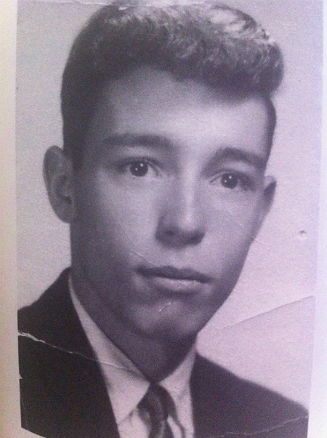
Vito was always a bright kid and a great student, and after high school graduation, he attended Fairleigh Dickinson University as an English major. The campus was, like most at the time, a homophobic environment, and Vito stuck out. He enrolled in a sociology class on minorities, and sat through a semester of discussion revolving around every class of minority except his own. He became fed up and asked the professor to discuss homosexuals as minorities, and when the professor asked him why, he became nervous and replied, “Because I know a lot of people who are gay.” Despite the bravery that simple declaration required, Vito was ashamed. Later in life, he gave an interview saying,
[It] stands out in my memory more vividly than anything else I’ve ever done. I don’t think I’ve ever been ashamed of anything as much as I was ashamed of that. And it hurt me so much to have to sit there and deny. I would never, ever do that again, I would never, ever deny – if anybody asked me, I would always admit. Because it hurt so much not to be able to stand up in front of that class and say, ‘I’m in your class; I’ve been in your class for two semesters now, and you’re talking around me.’
After that, Vito embraced his homosexuality on a public forum as well as privately. He became openly gay at home with his family. While the transition was initially difficult for his Catholic parents and proto-masculine brother, Vito benefited from a close-knit family who loved him fiercely for who he was. He organized campus screenings of The Children’s Hour and Scorpio Rising, the 1964 homoerotic experimental film by Kenneth Anger. He spent his down time visiting Fire Island and New York City, befriending Craig Rodwell, the owner and operator of the very first gay bookstore, Oscar Wilde Memorial Bookshop in Greenwich Village. There Vito discovered One magazine, the first gay political publication, and MSNY (Mattachine Society New York), one of the first gay rights associations.
Vito became awed by MSNY’s president Dick Leitsch, a manifestly political supporter of gay rights who led the charge against police harassment of gay bars in 1966. Leitsch scheduled an educational outreach tour to universities across the country, and Vito invited him to speak at Fairleigh Dickinson, further cementing him as a gay outcast at FDU. Leitsch’s passion for protecting gay rights started Vito on a lifelong quest. At Leitsch’s apartment, Vito met many others who shared his vehemence.
"It was the first time I ever heard gay people talk politics. Gay politics…they were simply talking about being allowed to live without being subject to attack."
After graduation, Vito moved to Manhattan permanently, thrilled to live within steps of Broadway, Greenwich Village and the heart of gay culture. He began working at Mama’s Chick’N’Rib, an infamous gay hangout in downtown Manhattan that provided a true community for Vito. He continued to spend his free time and every free cent at the movies or the theatre. He lived and loved freely, enjoying drag shows and gay nightclubs. But all around him, the atmosphere grew more malicious. Gays were being assaulted by citizens and police officers alike, and the most vocal part of the population continued a campaign of hate.
Vito began to feel like Greenwich Village was a ghetto, that he and his friends were ushered aside and made to live like criminals among the gay bars. Vito felt as if they were “being herded into dark, smelly places being controlled largely by organized crime and being exploited…a perception which I don’t think many of my friends shared.”
One of the dark, smelly places Vito frequented was The Stonewall, located at 53 Christopher Street, a gay bar run by three members of the Mafia. Despite its dank appearance and the constant threat of discovery, The Stonewall offered the best gay dance floor in the city – and more importantly, the freedom for gay men to dance with each other without hassle. On June 28, 1969, eight plainclothes police officers raided the bar, intending to arrest the 200 patrons there that night. Instead, the crowd rioted, and when Vito arrived about fifteen minutes after the riots were in effect, the situation was already at a crisis. The crowd grew and the scene turned uglier, with patrons and police officers injured.
The protest lasted for days, and though Vito only participated as a passive observer, he felt struck by the “spirit of rebellion.”
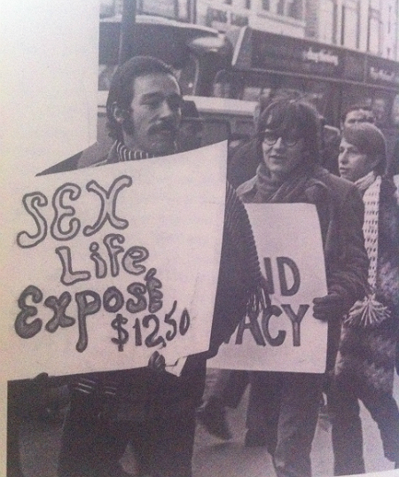
Two months later, Vito joined the Gay Activists Alliance. He began spending all of his time organizing GAA events and rallies, attending political meetings and waiting tables at the Omnibus, a posh restaurant for those in the literary, theatrical or gay communities. As part of the world’s first Gay Pride Parade in 1969, Vito rented 16mm prints of Laurel and Hardy’s Twice Two (1933) and the musical Gold Diggers of 1933 (1933). It was Vito’s first experience catering to an exclusively gay, film-loving audience, and he was hooked.
As Vito became more involved in the GAA hierarchy, he threw himself into his new life as an activist. Despite a quick temper, Vito was a peaceful person who respected the GAA’s commitment to non-violent protest. He appreciated that the GAA honored “the commitment to bring about change in the present, rather than theorize about change in the distant future.” Vito cared about now – he never understood the acceptance by gay people of their unjust lot in life. He was a passionate Italian who boiled at the prospect of living a hidden, hated life with no recourse. Vito would find that recourse. He would create it.
With GAA, Vito began a series of “zaps” intended to improve exposure to gay issues and embarrass public homophobes. By organizing protests and publishing essays, Vito’s voice was emerging as a strong defender of gay rights. Vito was a terrific writer and had a warm, engaging persona. People listened to him. They liked him. He began, with GAA, to draft progay legislation offering antidiscrimination policies for housing, public accommodation and employment. He reached out to gay people of color in order to create diversity within GAA’s ranks of mostly white, middle-class males.
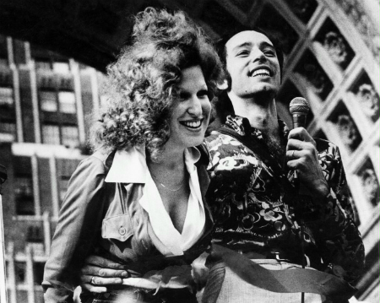
In 1973, Vito hosted the Gay Pride Gala in Washington Square Park. At first the event was a warm and loving celebration of gay culture, but as dissenting voices between lesbians, gay men and transgendered people escalated, the atmosphere turned hostile. Soon audience members were screaming at each other and throwing items on stage. Vito remained calm and insisted the audience let each protestor speak, and he had the presence of mind to invite Bette Midler on stage to charm the crowd back into peace. Vito was so grateful to Midler for offering “a tremendously healing presence…She said later that it was one of the great things she did, that she felt like she was Marilyn Monroe singing in Korea.”
At 24, Vito decided that a life in activism wasn’t enough for him professionally. He was sick of waiting tables and living as a “Greenwich Village faggot” with no professional direction. He began taking classes at NYU’s graduate cinema program, learning the language of film criticism and aestheticism while supplementing the curriculum with his private education in gay cinema by finding underground films such as Lot in Sodom (1933) and Pink Narcissus (1971). He learned about the technical aspects of filmmaking as well as the narrative, and his lifelong obsession became a realized passion.
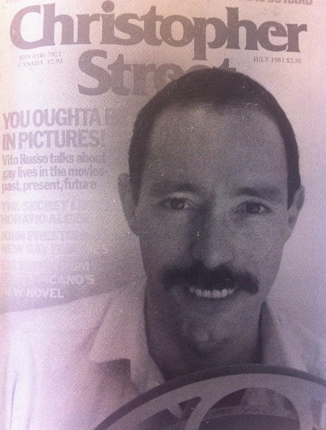
Vito became chair of GAA’s Culture (Arts) Committee, and started organizing Firehouse Flick nights, where he showed films that boasted a (sometimes arguably) gay sensibility such as Polanski’s The Fearless Vampire Killers (1967), Anger’s Fireworks (1947) and Advise and Consent (1962). And then Vito landed his dream job, an opportunity that would pave the way for his revolutionary masterpiece, The Celluloid Closet. He began working in the film circulation department at the Museum of Modern Art. He had access to the museum’s film archives, and he began a dedicated and thorough examination of “gay images and arcane camp” since the beginning of film.
He discovered a troubling trend: at first the instances of homosexuality in film were all comedic. They were clowns – sissies - to be laughed at, such as the Lion in The Wizard of Oz (1939) and Gus Leonard in drag in Bumping into Broadway (1919). Then gay characters grew to be sinister villains to be feared such as Barbara Stanwyck in Walk on the Wild Side (1962) and Gloria Holden in Dracula’s Daughter (1936). Finally, gay characters grew to be pathetic, miserable victims to be pitied, such as Shirley MacLaine in The Children’s Hour. In the movies, gay people must always die. They must be villains or victims or clowns, and they must always, always die. As feminist writer Susie Bright says in Celluloid Closet, this relentlessly negative portrayal affects gay audiences in a powerful way. About MacLaine’s breakdown in The Children’s Hour, she says:
The loathing she feels, how sick she is with herself…it still makes me cry to see that. You know, why am I crying? Why does this still get to me? This is just an old, silly movie, you know, people don’t feel this way anymore. But I don’t think that’s true. I think people do feel that way today still. And there’s part of me despite all my little signs, like Happy! Proud! Well-adjusted! Bisexual! Queer! Kinky! You know, no matter how many posters I hold up saying ‘I’m a big pervert and I’m so happy about it’ there’s this part of me that says ‘How can I be this way?’
And that portrayal, and the way it seeps into gay consciousness, is what Vito set out to acknowledge - because acknowledgement occasions change. Vito began writing reviews of theatre and cinema for GAY magazine, and soon less obscure publications, as well, such as Esquire, Moviegoer and Advocate. He started touring the country with screenings of the clips he’d amassed from the MoMA archives, unearthing all gay images in American cinema. These screenings were immensely popular with gay audiences; people flocked to the shows, and many said the screenings changed their lives. Bright adds,
It’s amazing how if you’re a gay audience and you’re accustomed to crumbs, how you will watch an entire movie just to see somebody wear an outfit that you think means that they are homosexual. The whole movie can be a dud, but you’re just sitting there waiting for Joan Crawford to put on her black cowboy shirt again. [in Johnny Guitar (1954)]
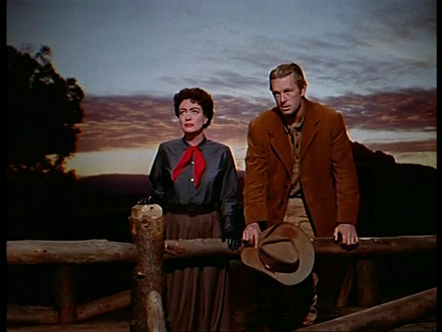
After ten years of touring colleges and cities around the country with his live lecture presentations and screenings, Vito was ready to put his life’s work on the page. In 1981, he published the first edition of The Celluloid Closet. In the book, Vito established the many ways that “homophobic stereotypes have both reflected and perpetrated the oppression of gay people.” The book also discusses scenes that were removed before the film was released, including an overtly sexual scene between Tony Curtis and Laurence Olivier in Spartacus (1960).
During his work on The Celluloid Closet, Vito befriended such performers as David Bowie, Elizabeth Taylor and Bette Midler, and he cultivated an especially close friendship with Lily Tomlin, whom he convinced to come out as a lesbian. Tomlin became one of the first Hollywood actors to openly acknowledge her homosexuality, and she later narrated the documentary film The Celluloid Closet that was produced after Vito’s death.
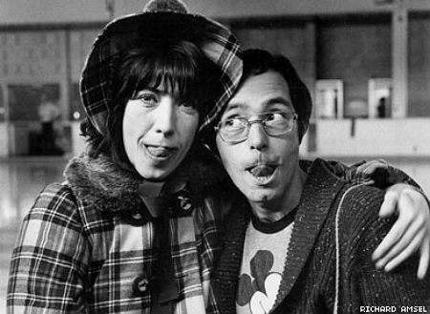
Throughout all of his cinematic proselytizing, Vito continued to grow as a political activist, as well. In order to combat the negative homosexual stereotypes in popular media, he co-founded the Gay and Lesbian Alliance Against Defamation (GLAAD), an organization that is still going strong today. He began writing, producing and hosting a public access series for the gay community called Our Time, which produced segments on gay culture, politics and news. He was the national publicity director for the 1985 Oscar-winning documentary film The Times of Harvey Milk. He received awards from the International Gay and Lesbian Film Festival and the Human Rights Campaign Fund. His handsome mug with the goofy grin was a staple at gay rallies and events. Vito was everywhere, because furthering the cause of gay rights was his life.
But soon, Vito found another cause to champion – the most significant endeavor of his life. In the spring and summer of 1981, Vito and those around him started to notice a siege of symptoms affecting those in the gay community. Fevers, sore throats, rashes, fatigue, muscle pains…out of nowhere, the epidemic was everywhere. Vito was terrified as his gay friends grew ill around him, and the government announced an outbreak of the newly named Gay-Related Immune Deficiency (GRID).
As the gay community fought illness and death, they were also forced to fight escalated hostility from the outside world. Conservatives maintained that God was punishing the sins of homosexuality, and those suffering from GRID were treated with disgust and horror. Dr. Paul Cameron of the American Psychological Association called gay men “worse than murderers.” Jerry Falwell demanded that AIDS victims be quarantined. Republican Senator Jesse Helms demanded that HIV be among the list of excludable diseases preventing travel and immigration to the United States, and he was fervently opposed to federal funding of AIDS research and treatment. The public voice was ruinous.
As those closest to Vito were struck with the illness – now named AIDS – he became more incensed at the government’s negligence. No funds were delegated to the research of this devastating disease. It was a gay problem, and therefore, not America’s problem. But when Vito’s lover and companion of five years, Jeffrey Sevcik, was diagnosed with the virus, Vito flew into action. He began to work as a media consultant for the San Francisco AIDS Foundation, promoting a policy of safe sex, prevention, education and funding for AIDS research. Vito threw himself into caring for Jeff and his work for SFAF.
On August 13, 1985, Vito was diagnosed with AIDS. He was told that he had about a year to live. Vito became resolved to “think clearly, have hope, be strong, not give in, not despair for [himself] and for all the fine loving people around [him].” He would not let his illness define him. He would make a difference with the time that he had left. He was dealt a crippling blow when Jeff passed away on March 5, 1986, but Vito took the grief of losing the love of his life and turned it into fuel.
As he continued to work with SFAF, GAA and GLAAD to effect change, Vito felt that not enough was being done to combat AIDS. In March 1987, Vito founded the first direct AIDS action group, the AIDS Coalition to Unleash Power (ACT UP). Members of ACT UP made it a priority to reach out to non-gay communities affected by AIDS: prostitutes, African-Americans, Haitians and Hispanics. As the disease wrecked his body, Vito never slowed down. He attended innumerable rallies and protests and concerts, never allowing his weakening health to impede his relentless agenda.
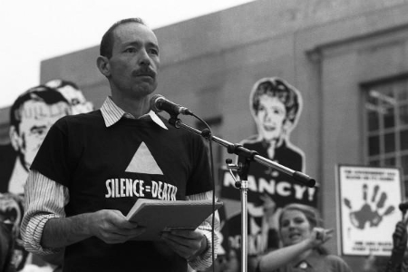
At the ACT UP demonstration in Washington, D.C. in October 1988, Vito gave a speech entitled “Why We Fight” that moved a crowd of thousands to tears and deafening applause. He indicted the government and media for negligence and outright destruction.
So, if I’m dying from anything, I’m dying from homophobia. If I’m dying from anything, I’m dying from racism. If I’m dying from anything, it’s from indifference and red tape, because these are the things that are preventing an end to this crisis. If I’m dying from anything, I’m dying from Jesse Helms. If I’m dying from anything, I’m dying from the President of the United States. And especially if I’m dying from anything, I’m dying from the sensationalism of newspapers and magazines and television shows, which are interested in me as a human interest story – only as long as I’m willing to be a helpless victim, but not if I’m fighting for my life.
If I’m dying from anything, I’m dying from the fact that not enough rich, white, heterosexual men have gotten AIDS for anybody to give a shit. You know, living with AIDS in this country is like living in the Twilight Zone. Living with AIDS is like living through a war which is happening only for those people who happen to be in the trenches. Every time a shell explodes, you look around and you discover that you’ve lost more of your friends, but nobody else notices. It isn’t happening to them. They’re walking the streets as though we weren’t living through some sort of nightmare. And only you can hear the screams of the people who are dying and their cries for help. No one else seems to be noticing.
And it’s worse than a war, because during a war people are united in a shared experience. This war has not united us; it’s divided us. It’s separated those of us with AIDS and those of us who fight for people with AIDS from the rest of the population.
On November 7, 1990 – five years after he received his diagnosis - Vito Russo passed away. He spent his last days surrounded by his family and friends, those who loved him and those he loved. His legacy lives on through GLAAD and through the powerful change that ACT UP created with AIDS prevention, research funding, treatment efforts and a national educational program. The GLAAD Media Awards present the Vito Russo Award in his honor to openly gay or lesbian celebrities who offer outstanding contributions to the gay community. Merrill College at UC Santa Cruz established the Vito Russo House to provide safe, comfortable living to GLBT and straight-supportive students and to promote GLBTA awareness.
But most of all, Vito’s legacy will live on through his magnum opus, The Celluloid Closet. Countless readers have discovered glimpses of themselves through Vito’s inexorable research, just as he found a glimpse of himself while watching Montgomery Clift and John Ireland flirt and shoot in Red River. Vito Russo loved Hollywood; he also held Hollywood accountable. He wanted more from movies, and he never stopped believing they could provide more. In the intro of The Celluloid Closet, Vito quotes Samuel Goldwyn from 1938:
“Most of our pictures have little, if any, real substance. Our fear of what the censors will do keeps us from portraying life the way it really is. We wind up with a lot of empty fairy tales that do not have much relation to anyone.”
Vito fought for substance. He fought to relate to what he saw onscreen. Vito Russo fought for change – and he accomplished it.
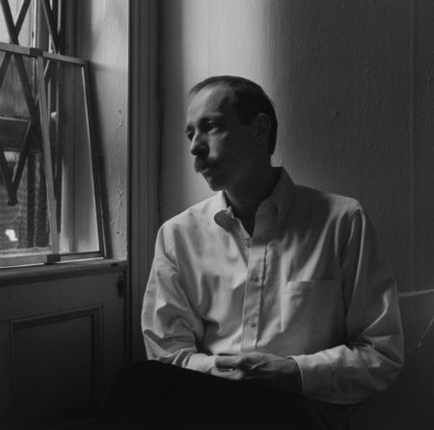
Sources:
I learned about Vito Russo through a variety of exceptional sources. First and foremost, the book Celluloid Activist: The Life and Times of Vito Russo by Michael Schiavi is a penetrating and informative look into the life of this wonderful man. Read the book – it’s fascinating and fun, and this post wouldn’t exist without it.
The Celluloid Closet is currently out of print, but you can find it lots of places. Vito’s voice is biting and brilliant, and the book is a must read for cinephiles and lovers of gay culture.
The documentary film based on The Celluloid Closet is also great, because you can actually watch the clips Vito details in the book. Both book and film are crucial for your library.
I first learned about Vito Russo by watching Vito, an incredible documentary by director Jeffrey Schwarz at the Dallas International Film Festival. The documentary airs on HBO next month, and I pretty much insist you watch it.
You can read the full text of Vito’s “Why We Fight” speech here.
Categories: The Badass Hall of Fame Tags: Badass Hall of FameCelluloid ClosetThe Badass Hall of FameVito Russo
About the Author: Meredith is the managing editor of Badass Digest, Fantastic Fest, The Alamo Drafthouse and Birth.Movies.Death. She's shorter than you might think.

